1. Title of the Experiment
To study and simulate a single-server queueing system using GPSS

2. Objective
To model and analyze a single-server queue system using GPSS (General Purpose Simulation System) and study system performance such as queue length and server utilization.

3. Theory
GPSS (General Purpose Simulation System) is a discrete-event simulation language used to model systems like queues, production lines, computer systems, and communication networks.
In GPSS:
- The system is modeled using blocks

- Transactions move through blocks

- Each block represents an activity such as arrival, waiting, service, or departure

Common GPSS blocks:
- GENERATE – creates transactions (arrivals)

- QUEUE – represents waiting line

- SEIZE – captures a facility (server)

- DEPART – removes transaction from queue

- ADVANCE – service time

- RELEASE – frees the facility

- TERMINATE – ends the simulation

4. System Description
We consider a single-server queue system with the following assumptions:
- Customers arrive randomly

- Only one server is available

- Customers wait in a queue if the server is busy

- Service time is fixed

- Simulation ends after a fixed number of customers

5. Model Assumptions
- Inter-arrival time = 5 time units

- Service time = 8 time units

- One server

- Total customers simulated = 10

6. GPSS Block Diagram
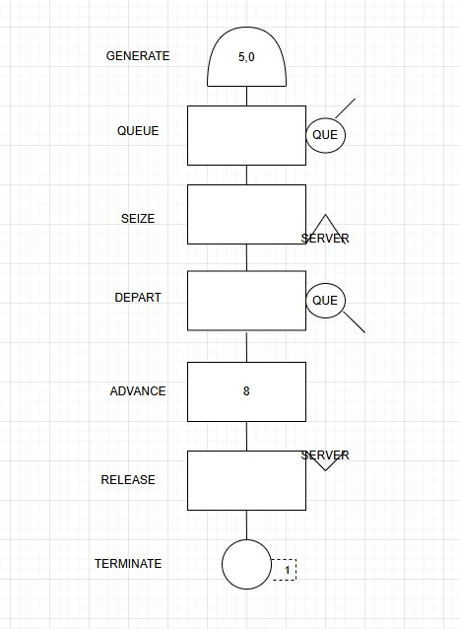

7. GPSS program
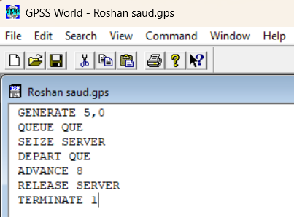
8. Simulation output
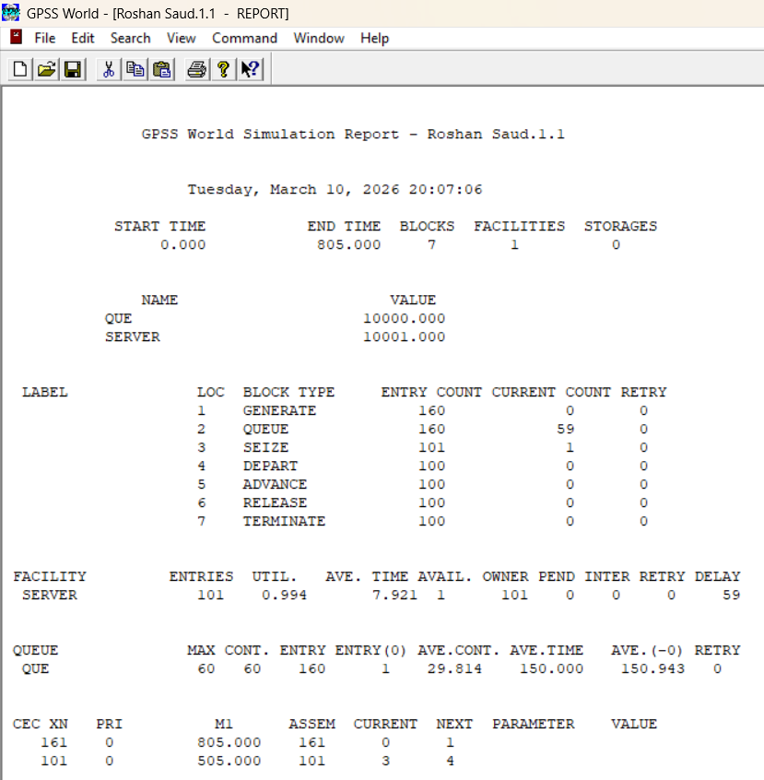

9. Result
The GPSS simulation successfully models a single-server queueing system.
Customers wait in the queue when the server is busy, and system performance measures are obtained.

10. Conclusion
GPSS is an effective simulation tool for analyzing real-world queueing systems.
By changing arrival or service times, system behavior and performance can be easily studied.

